2020 Timetable
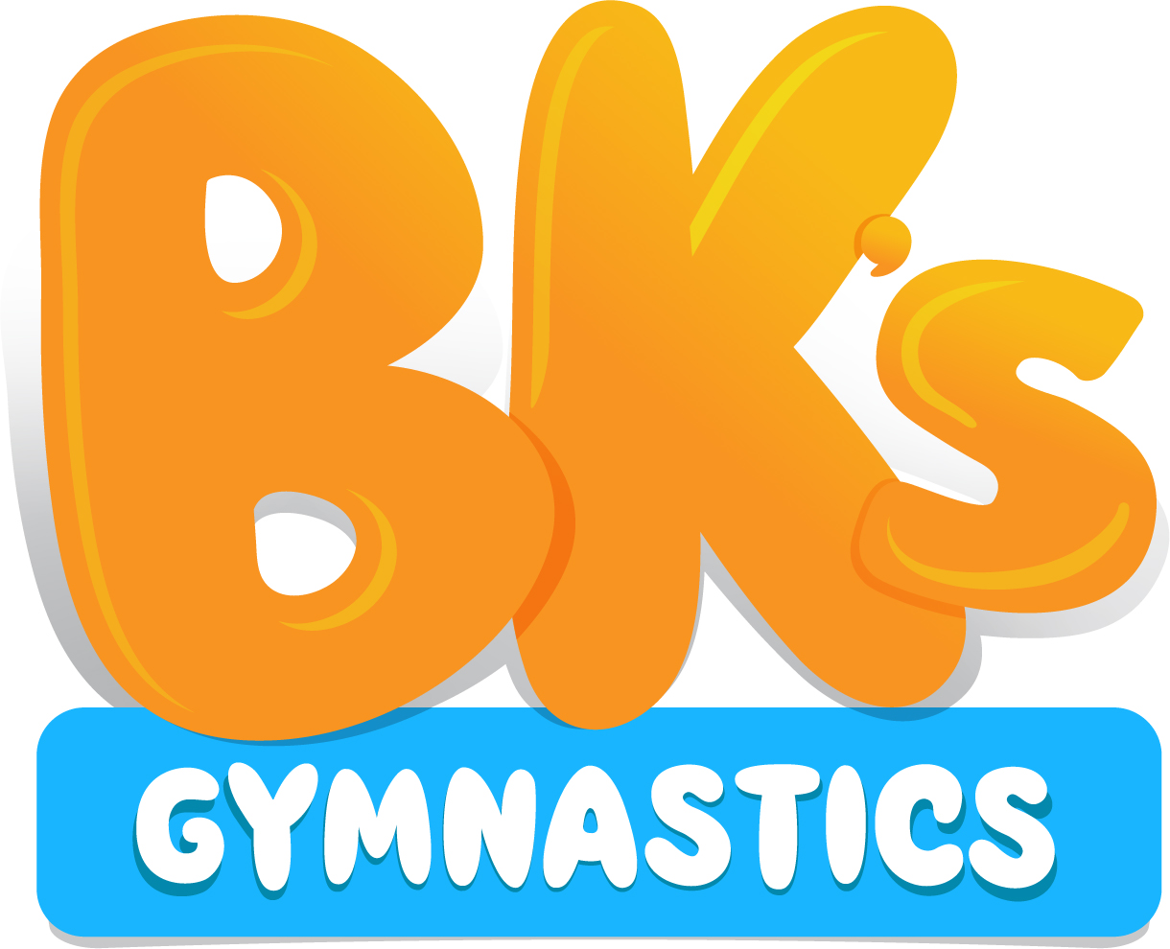

Pre School Classes
 | Monday | Tuesday | Wednesday | Thursday | Friday | Saturday
Baby Gym  (4 month – 2 years) |  | 10am – 10.45am |  |  | 10am – 10.45am
Kinder Gym  (2 – 5 years) |  | 11am – 11.45am | 10am – 10.45am  11am – 11.45pm | 10am – 10.45am  11am – 11.45pm | 11am – 11.45am | 9am – 9.45am

Recreational Classes
 | Monday | Tuesday | Wednesday | Thursday | Friday | Saturday
Gym Fun (5 to 8 years) | 4pm to 5pm | 4pm to 5pm  5pm to 6pm |  | 4pm- 5pm  5pm – 6pm |  | 10am – 11am
Gym Skills (8 - 10 years) | 5pm to 6pm | 4pm to 5pm  5pm to 6pm |  | 4pm – 6pm |  | 10am – 11am  11am- 12pm
Teen Gym Skills (10+) |  | 4pm – 6pm |  |  |  | 10am – 12pm
Gym For Me (12 - 17 years)  Term 2 onwards |  |  | 5pm to 6pm

Gymstar Classes
 | Monday | Tuesday | Wednesday | Thursday | Friday | Saturday
Gymstar 2 (2hrs) | 4pm to 6pm
Gymstar 3 (3hrs) | 4pm to 7pm
Gymstar 4 (4hrs) | 5pm to 7pm |  | 5pm to 7pm
Gymstar 5 (5hrs) |  |  | 4pm to 6pm |  | 4pm to 7pm
Gymstar 6 (6hrs) |  |  | 4pm to 7pm |  | 4pm to 7pm

Other Programs
 | Monday | Tuesday | Wednesday | Thursday | Friday | Saturday
Free Jump (5 to 8 years) |  | 4pm to 5pm |  | 4pm to 5pm
Free Vault (8 to 12 years) |  | 5pm to 6pm |  | 5pm to 6pm | 5pm – 6pm

Women’s Artistic Gymnastics (WAG)
(Invitation Only)
 | Monday | Wednesday | Friday
Level 3 | 4 – 7pm | 4 – 7pm | 4 – 7pm
Level 4 | 4 – 7pm | 4 – 7pm | 4 – 7pm
Level 5 | 4 – 7pm | 4 – 7pm | 4 – 7pm
Level 6 | 4 – 7pm | 4 – 7pm | 4 – 7pm

Adult Classes
 | Monday | Tuesday | Wednesday | Thursday | Friday | Saturday
Adult Class (16 years +) |  |  | 7pm – 8.30pm

